Full Name
Email ID
Contact No
Enrollment Number
Year & Stream

Section (LAB)
1st Half | 2nd Half
Date:
Subject Name:
Subject Code:

Q.1(AIM)➔ Implementation of basic gates// realization of the basic gates

Apparitor Use:win7, logisim

Source Code: (Screen Short):
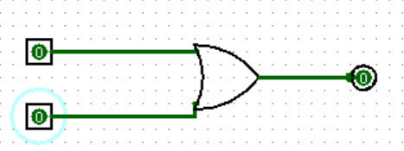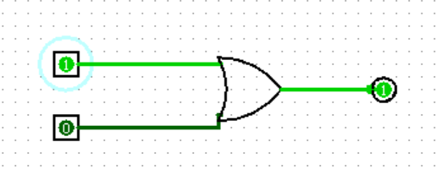

Output (Screen Short): OR Gate

I/P1 | I/P2 | O/P
0 | 0 | 0
0 | 1 | 1
1 | 0 | 1
1 | 1 | 1

Conclusion:

